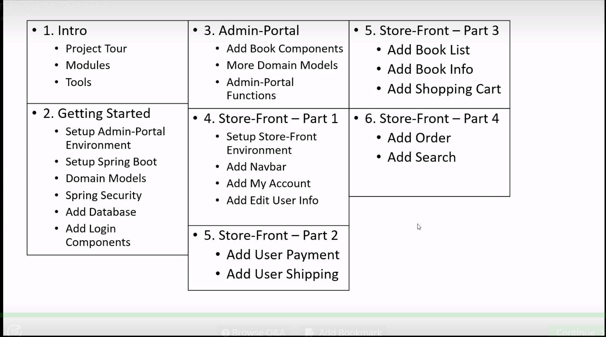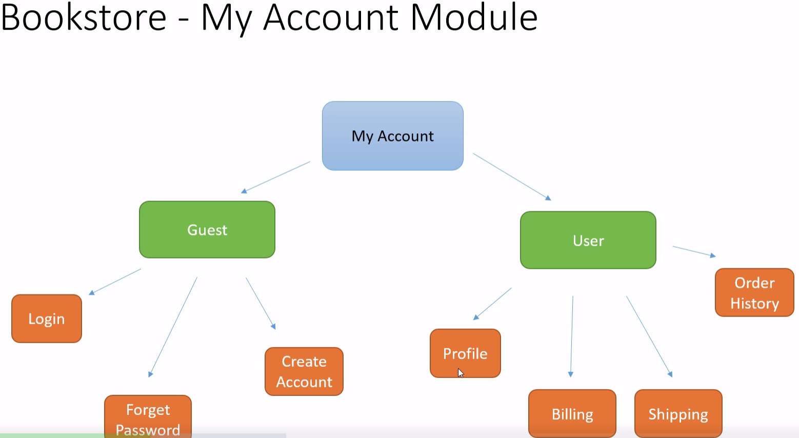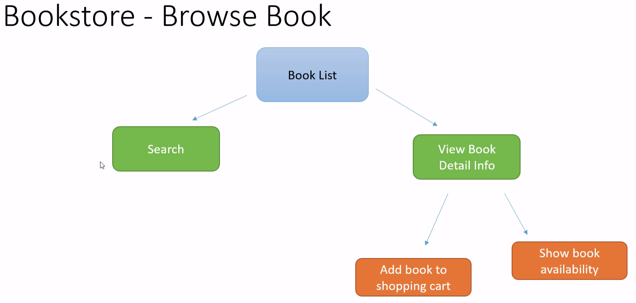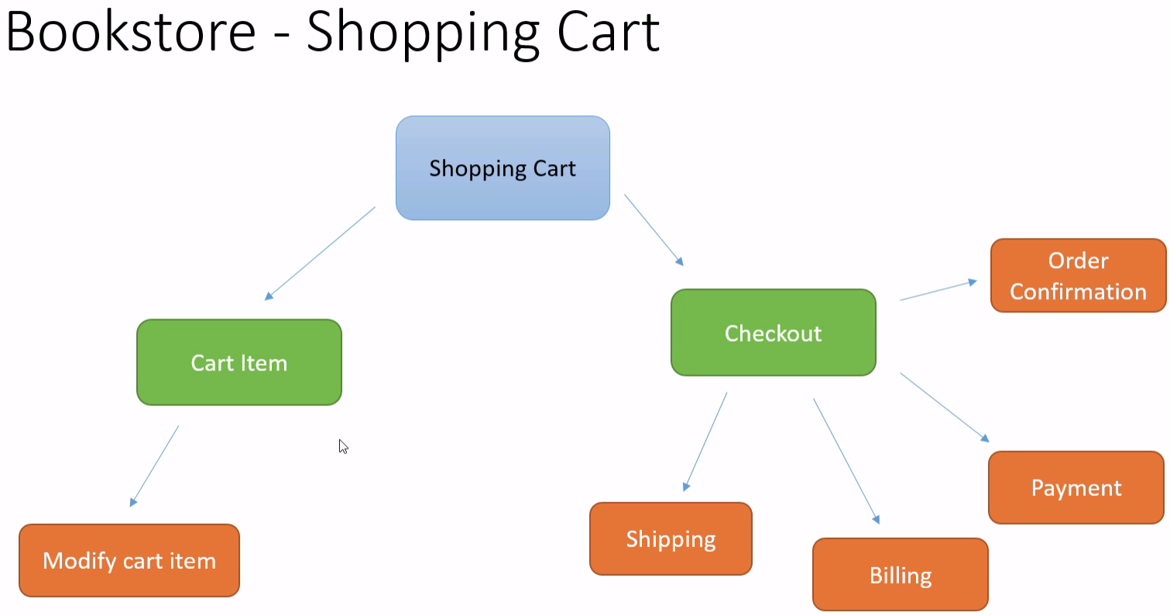

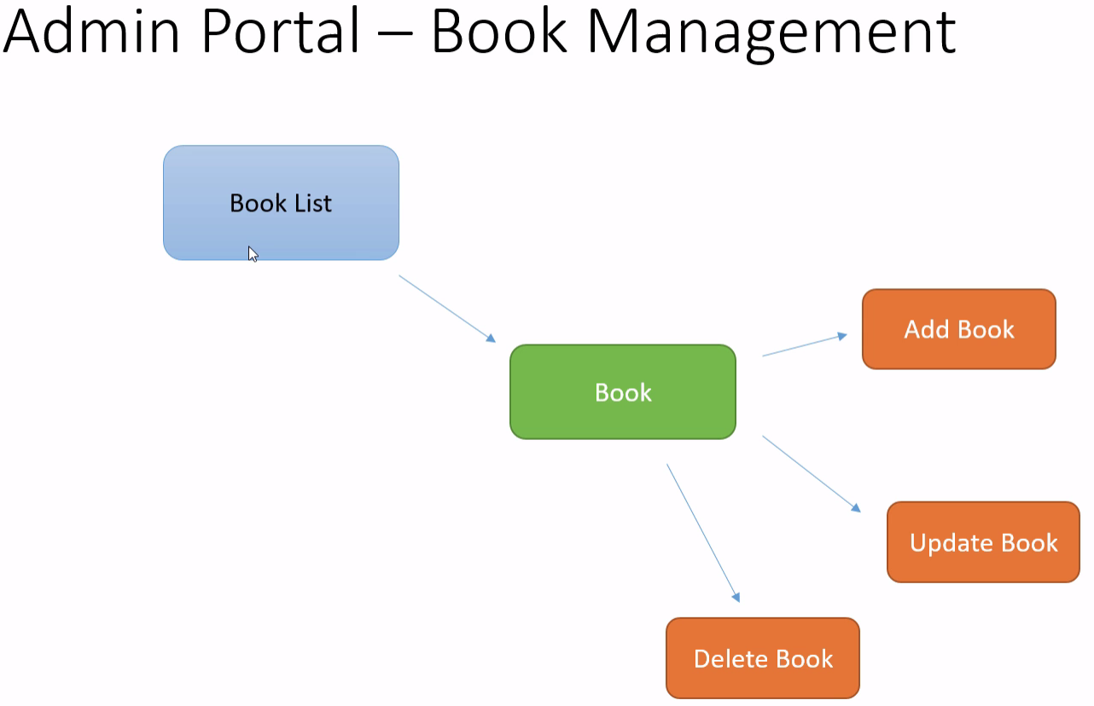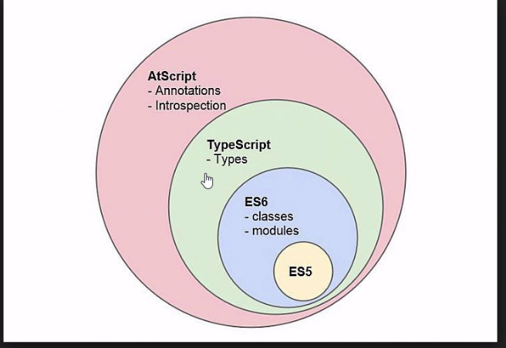

Section: 1 Module-5

Tool:

1. Typescript language (Superset of JavaScript by Microsoft open source)
2. Typescript editor (1) **sublime text** (2) Atom
3. Typescript plugin (include in to editor)
4. Angular cli
5. Angular2 martials(Readymade component)
6. Bootstrap css framework (getbootstrap.com)(hammerjs JavaScript lib)
7. Node.js and NPM latest version (Nodejs.org)
8. Java 1.8
9. Spring framework
10. Spring boot
11. Spring data
12. Spring security ext..
13. **Spring session using redis server (Do we need to do extra setup on prod machine)**
14. **Hibernate as orm (with spring data)**
15. Eclipse Neon
16. MySQL (Community version)
17. MySQL workbench

**Section:2 Module-1**

**Angular Cli:**

* Is command tool or terminal tool for angular2? (Official tool from angular)
* Is easy to bootstrap your angular project like springboot project.
* Show how to install
* cli.angular.io
* **Module -7**
* **Lecture -8**
* **Lecture -9**
* **Lecture-10 – Session management**
* 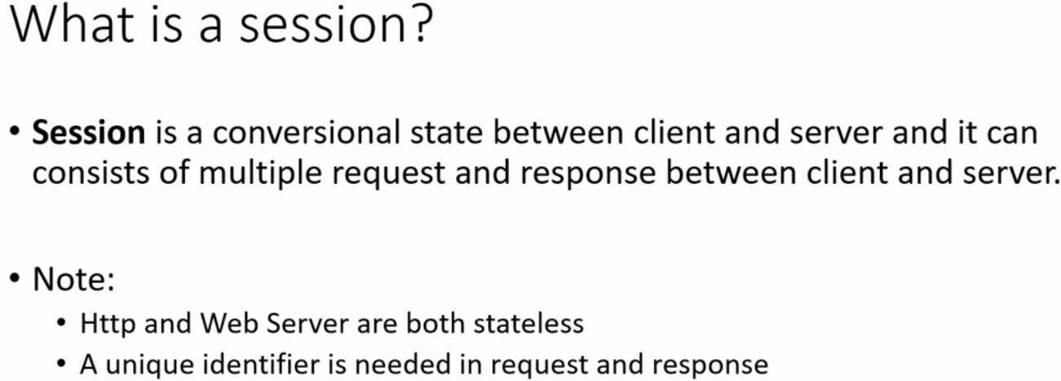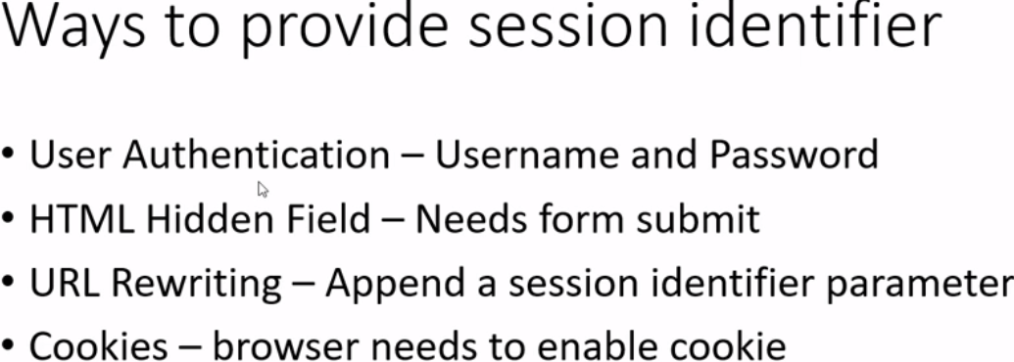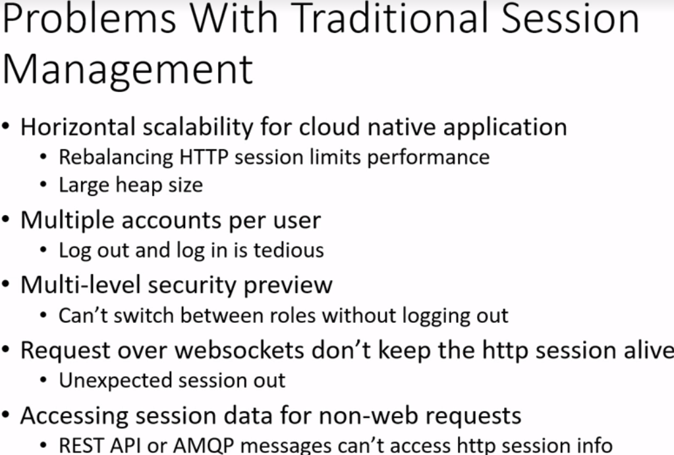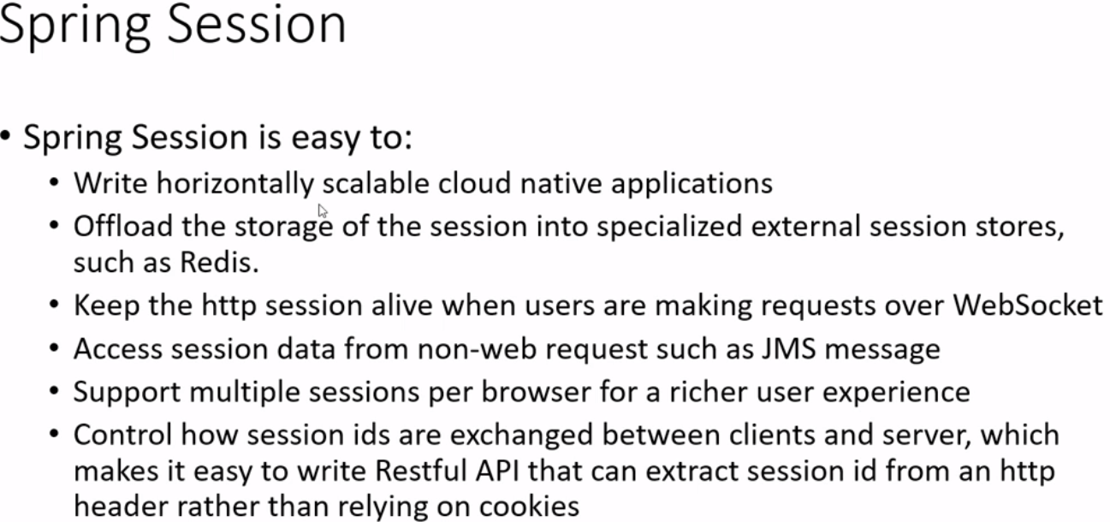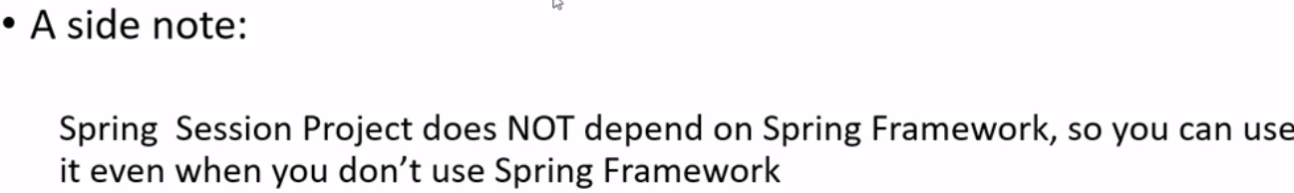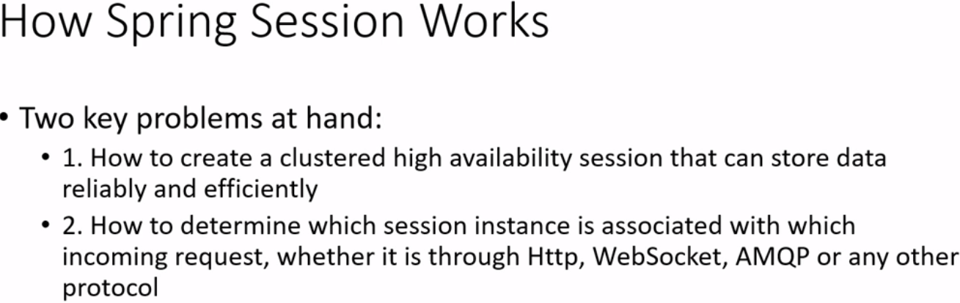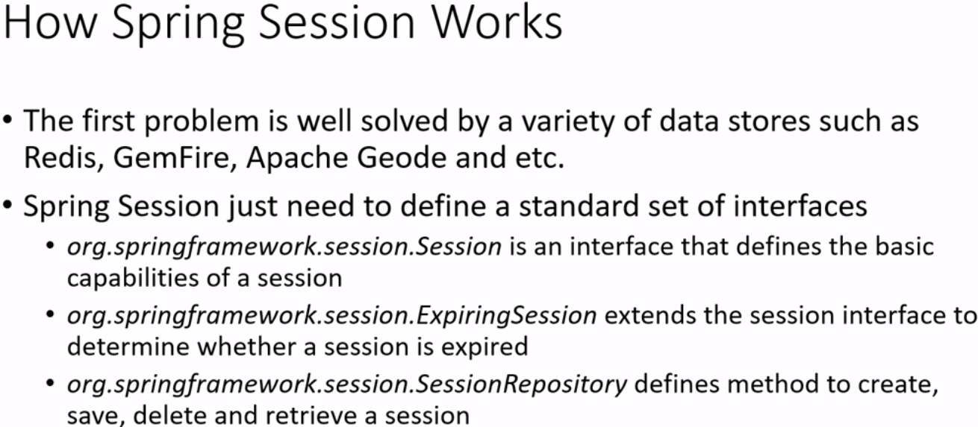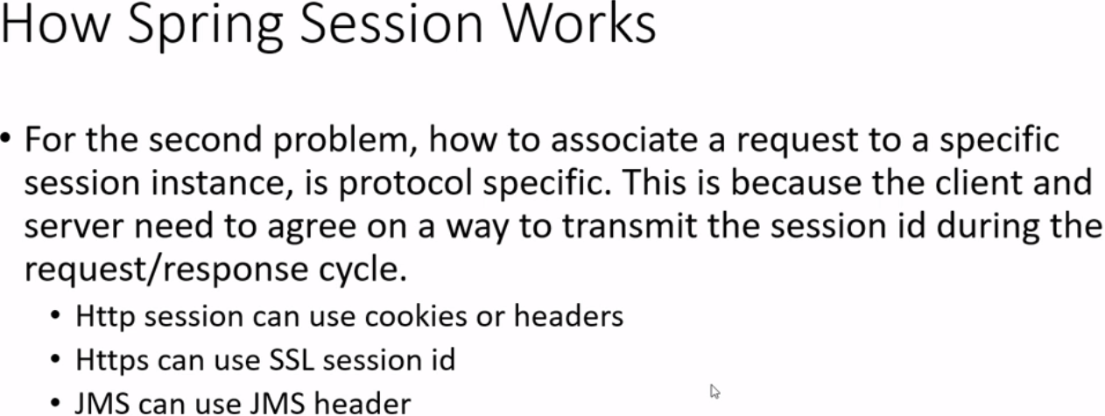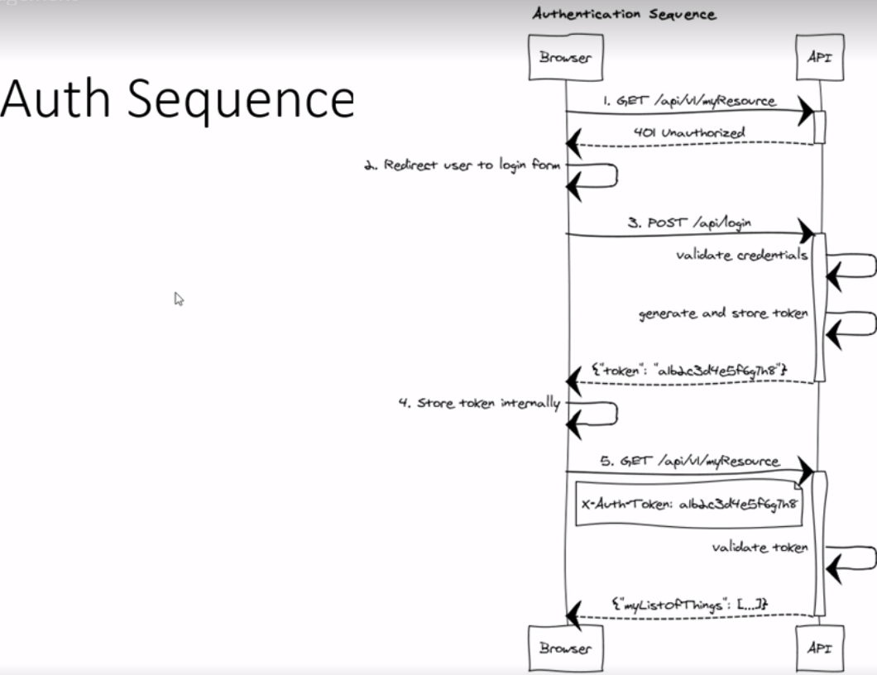
* **Lecture -11 Spring Boot**
* 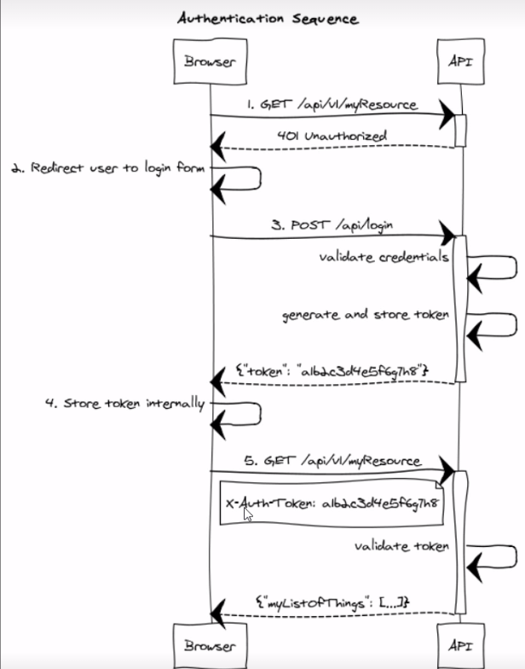
* **Lecture 12 Entity diagram (draw.io)**
* 